## JS Back-End Exam – Charity Christmas

## Exam Rules:

1. You have **4 hours**
2. When you are ready, delete the ***node_modules***folder, make sure all dependencies are listed in the ***package.json*** file and submit your archiving project.
3. You are provided with **HTML & CSS** resources
4. You may **add attributes** (such as **class** and **dataset**), but it is forbidden to **change** **existing** attributes (such as **class** and **id**)
5. You may **change "href"** attributes on links and add/change the **method** and **action** attributes of HTML Forms.
6. Use **Express.js** as a back-end framework
7. Use **MongoDB** as a database with [**mongoose**](https://mongoosejs.com/docs/)
8. You can use whatever **view engine** you like ([**express-handlebars**](https://www.npmjs.com/package/express-handlebars), EJS, Pug, etc.)
9. Use [**bcrypt**](https://www.npmjs.com/package/bcrypt) **for hashing the password**
10. The application **must start** from the file **"index.js"** on port **3000**
11. It is **forbidden** to **use** **React**, **Vue**, **Angular,** etc.
12. **Only the last submission will be evaluated!**

## Application Overview

Get acquainted with the provided **HTML and CSS** and create an application for the **sale of toys for charity**.

The visitors can **view** the **Home page** and **Catalog** page with available toys. They can also **register** with an **email**, **username**, and **password**, allowing them to create their post and **buy toys they are interested in** (if the **current user** is **not** the author of the post). Authors can edit or delete posts at any time.

## Functional Requirements

### Guest (not logged in)

**Guest** navigation example:



The **application** should provide Guest (not logged-in) users with the functionality to Login, Register, and **view** the Home page, **Catalog** page, and **Details** page.

### Users (logged in)

**User** navigation example:



The **application** should provide **Users** (logged in) with the functionality to:

* **View the Home page and all other pages with logged-in navigation**
* **View Catalog page**
* **Create а new Toy Post [Create Toy]**
* **Access the toy details page [Details]**
* **Buy toys (**if the **current user** is **not** the **owner of the toy’s post)**
* **Delete or Edit the post depending on the user's authentication (only for the owner of the current toy’s post)**

## Database Models

The **Database** of the **Charity Christmas** application needs to support **two entities**:

### User

* Username - string (required),
* Email - string (required),
* Password - string (required)

### Toys

* **Title - String (required),**
* **Charity - String (required),**
* **Image - String (required),**
* **Description - String (required),**
* **Category - String (required),**
* **Price – Number (required),**
* **BuyingList - a collection of Users (a reference to the User model)**
* **Owner - object Id (a reference to the User model)**

**Note:** When a user **buys toys**, their **id** is added to that collection (**Buy toys**)

Implement the entities with the correct data types.

## Application Pages (80 pts)

#### Home Page (For logged in users and logged-out users)

Visualize **static home page**.

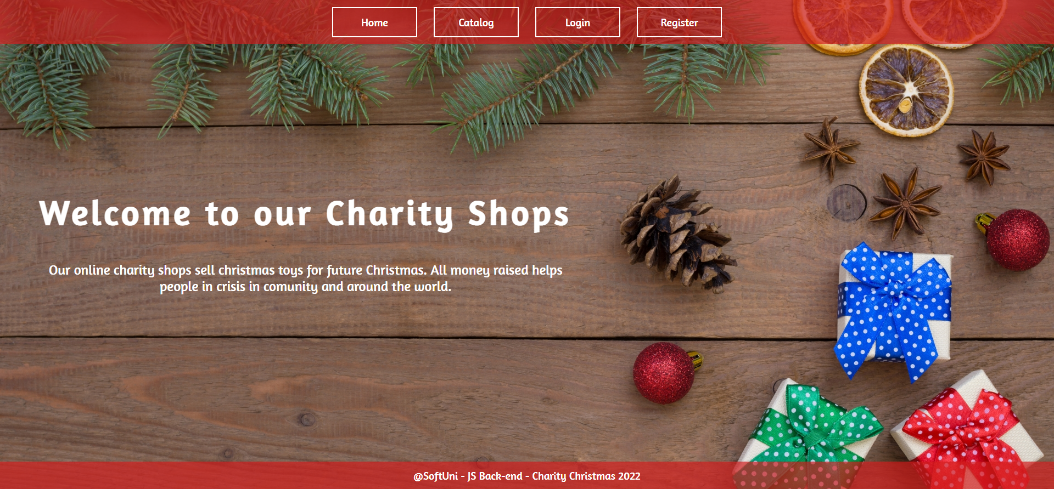

#### Register Page (Logged Out User)

**Register** a user inside the Database with a **username, email, and password**. **Password** inside the **Database** must be hashed (**use bcrypt**), and both passwords **must match**! After successful registration, you should **redirect** to the **Home page**.

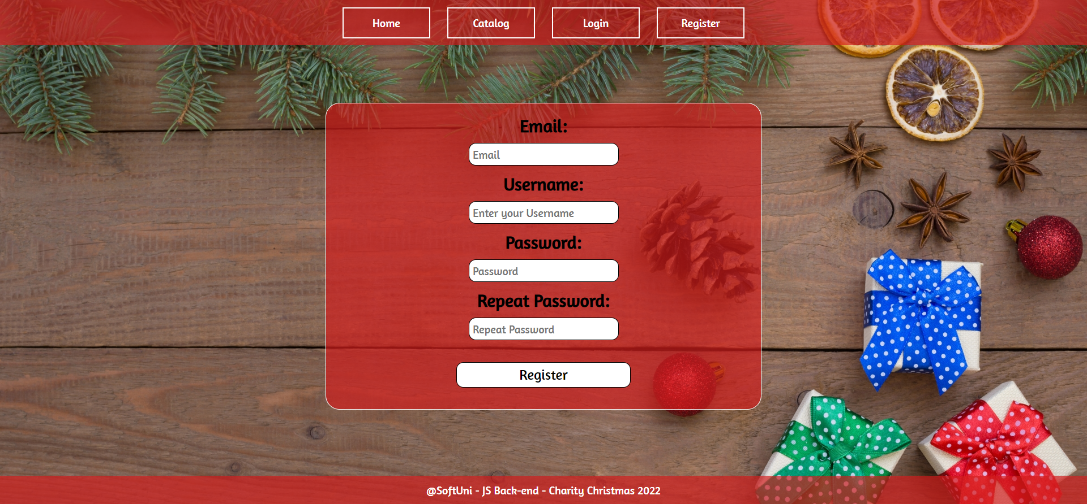

#### Login Page (Logged Out User) - (5 Pts)

Logging an already registered user with the correct **email** and **password**. After successful login, you should **redirect to the Home page.**

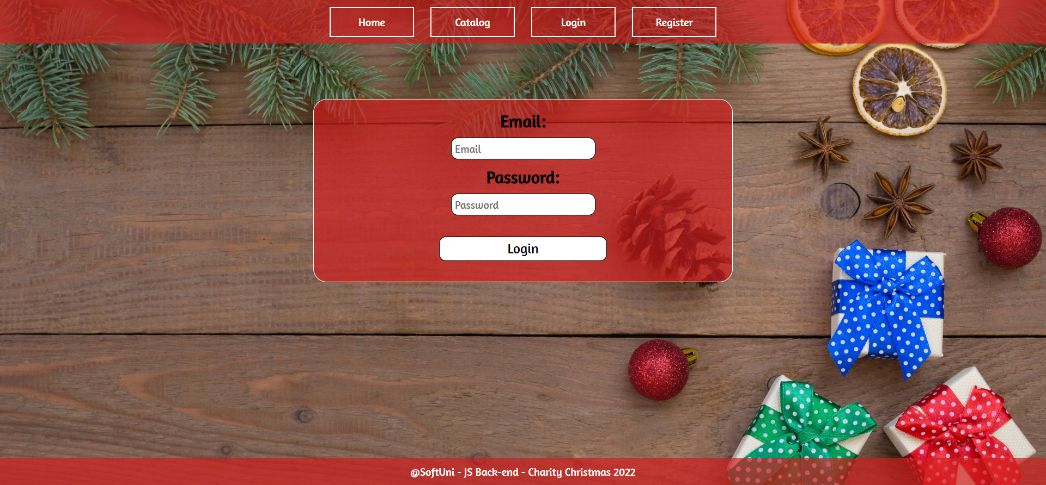

#### Logout (logged in user)

The logout action is available to **logged-in** users. Upon success, clear any session information and **redirect** the user to the **Home** page.

#### Create Toy (Logged in User)

The **Create** page is available to **logged-in users**. It contains a form for adding a new toy post. Upon success, **redirect** the user to the **Catalog** page.

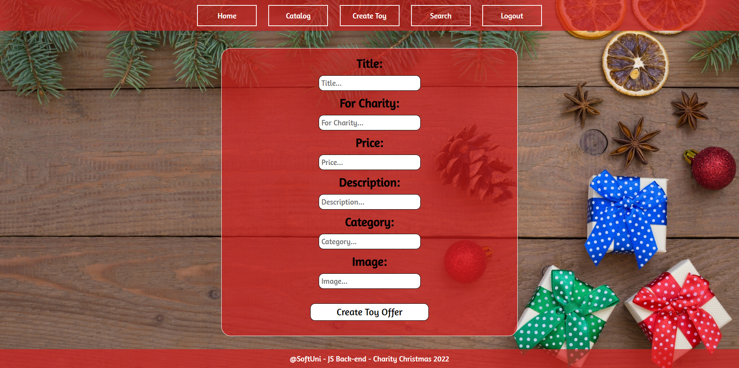

#### Toy Catalog (For logged in users and logged out users)

List all toy posts. Each post must display information about the **title, price, and image** and a button for **details** (**a** tag) about the **specific toy post**. As in the picture below:

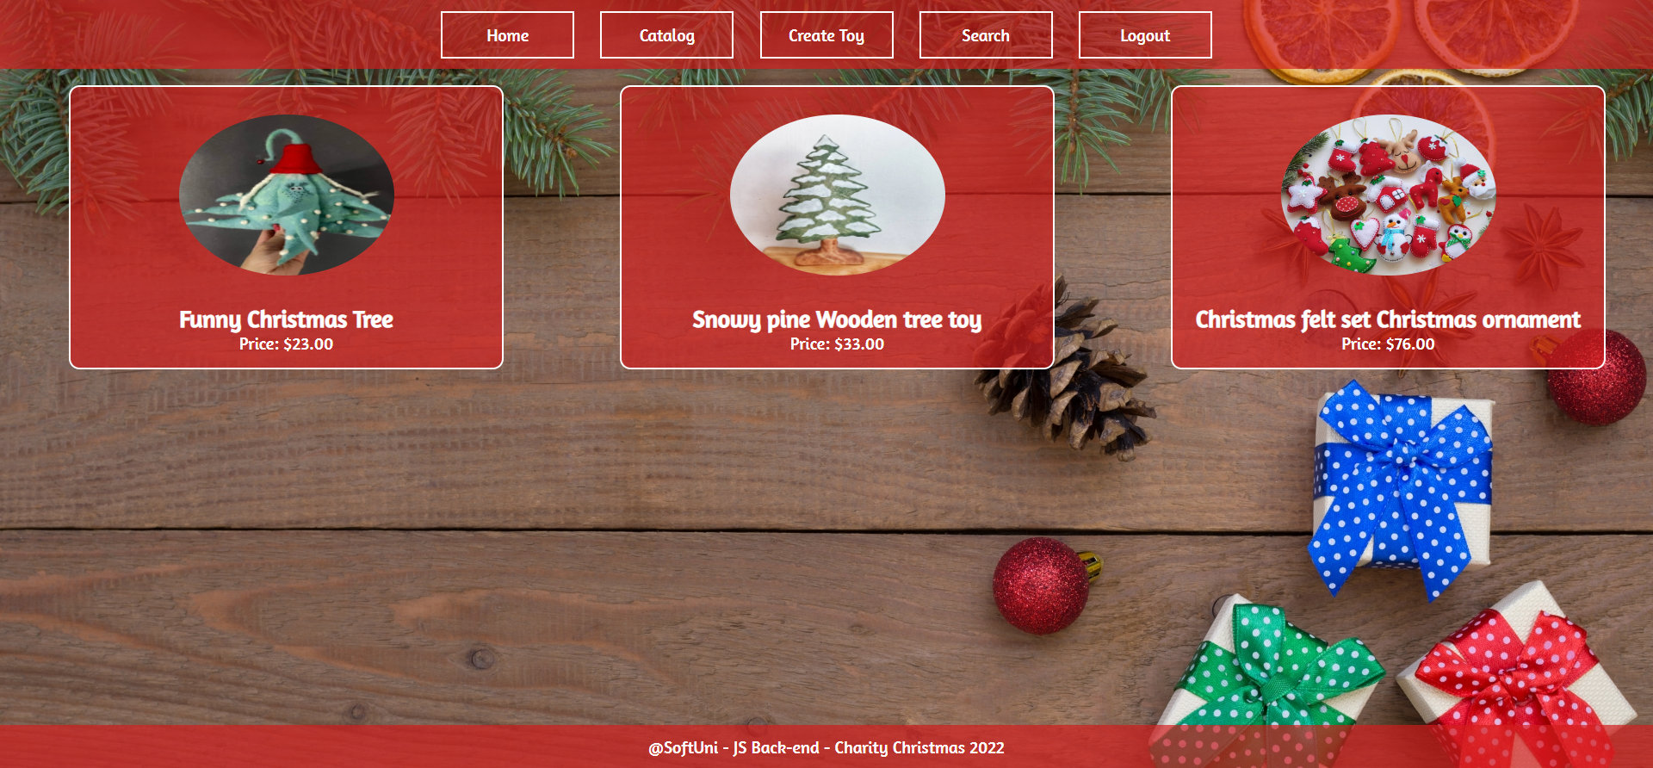

**The details** button **(a** tag**)** should be a link to the **details** **page** for the current toy post.

If there are **NO** posts in the Database yet, display **"There are no toys found..."**

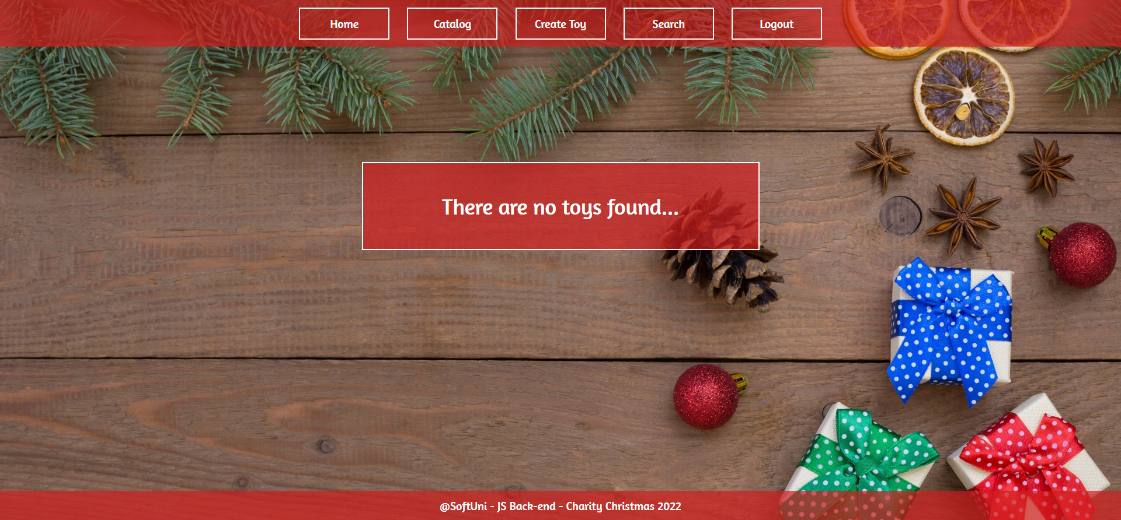

#### Details Page - (for logged in users and logged out users)

All users should be able **to see details**. Clicking the **details button (a** tag**)** on the toy card should display the details page. If the currently registered user **is the creator** of the toy post, the **Edit** and **Delete** buttons should be displayed. Otherwise, they **should not be available**.

Information about the blog:

* **Title**
* **Image**
* **Charity**
* **Category**
* **Description**
* **Price**
* **Buttons** (Depending on the status of the currently logged in user)

#### Details Page (logged out users)

If there are **no logged**-in users, **no buttons** should be displayed.

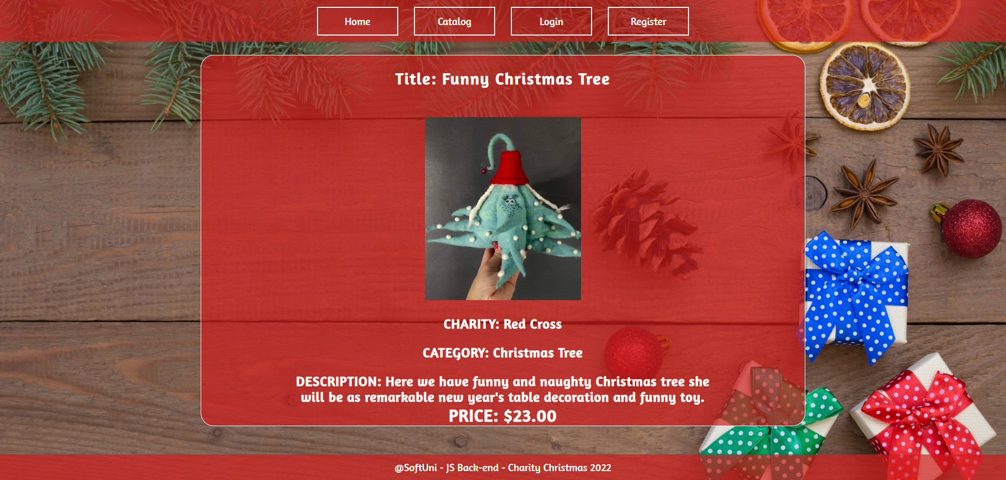

#### Details Page (logged in user and creator of the current blog)

If the **currently logged-in** user is the **owner** (the user who **created the toy post**), he should see the **[Delete]** and **[Edit]** buttons.

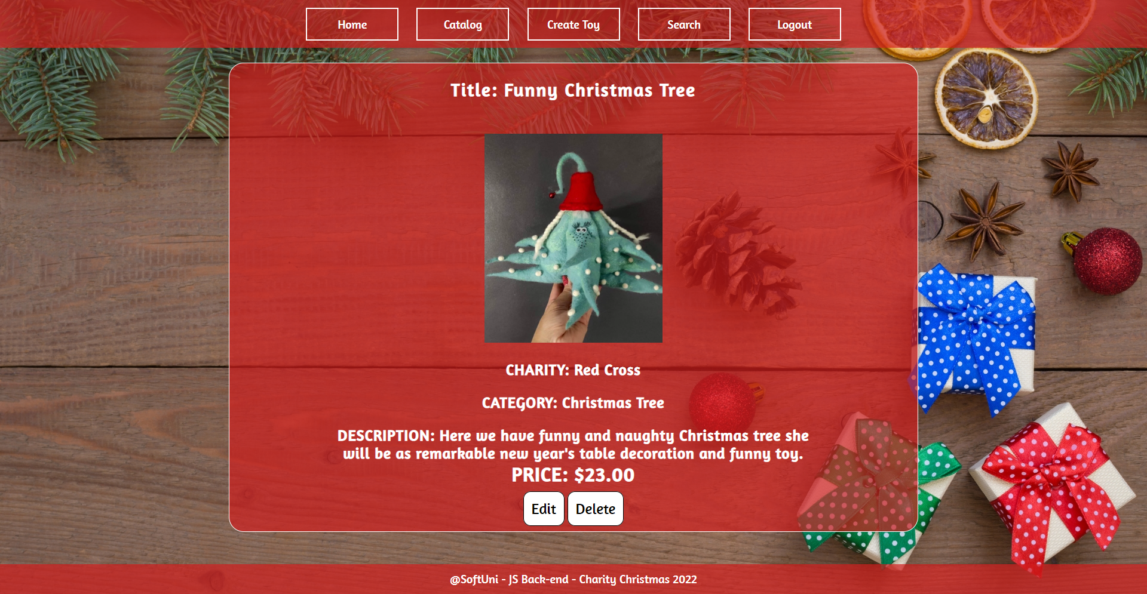

#### Details Page (logged in user who is not bought)

If the currently logged-in user is **not already bought** (a user who is **not** the creator of this toy post), he should see a **buy** button.

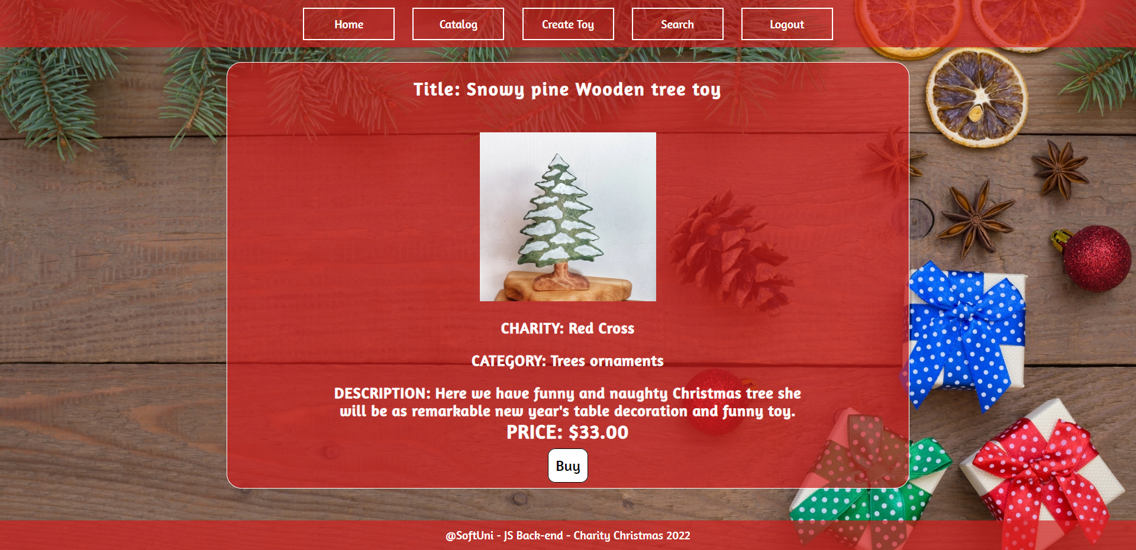

#### Details Page (logged in user already bought toy)

If the currently logged in user **is not the owner** and has **already bought that toy**, he should see **[Thank You For Your Purchase 😊].**

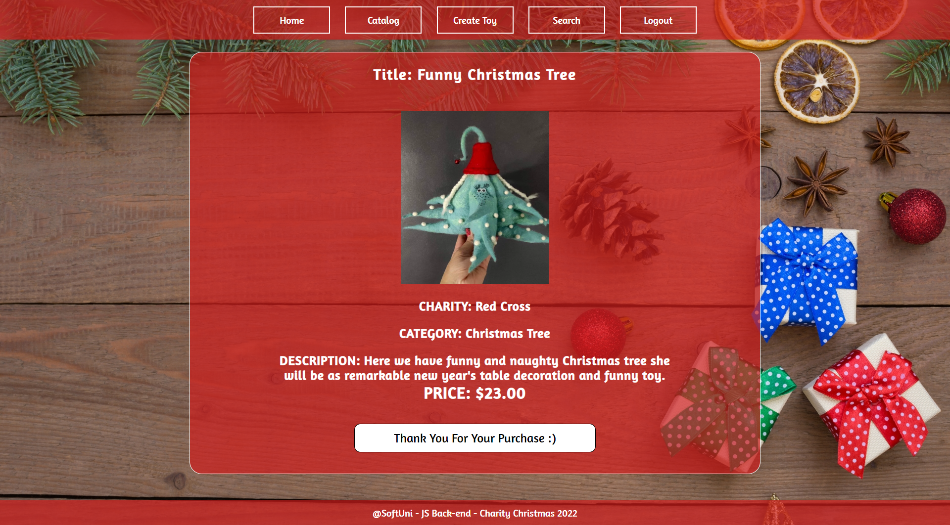

#### Buy (logged in user who is not the current post owner)

Any registered user who is **not** the current **owner** of the toy post must be able **to buy that toy** (if any).

If he manages to **buy the toy successfully**, his **userId** must be added to the collection of **buyingList** and **redirect** the user to the **Details** page for the current **toy post**.

If a user has once bought the current toy, he should see " **Thank You For Your Purchase 😊**".

#### Delete Toy (logged in user and owner of the current toy)

Each **owner** of the toy post must be able to click on the **[Delete]** button and **delete the current toy post** from the Database, and the user must be redirected to the **Catalog** page.

#### Edit Toy (logged in user and owner of the current blog)

Each **owner** can edit their **toy post**. Clicking the **[Edit]** button for a specific post on the details page should display the **Edit page**, all fields being populated with toy data. It contains a form with input fields for all relevant properties. If **successful**, redirect the user to the **current toy post details page**.

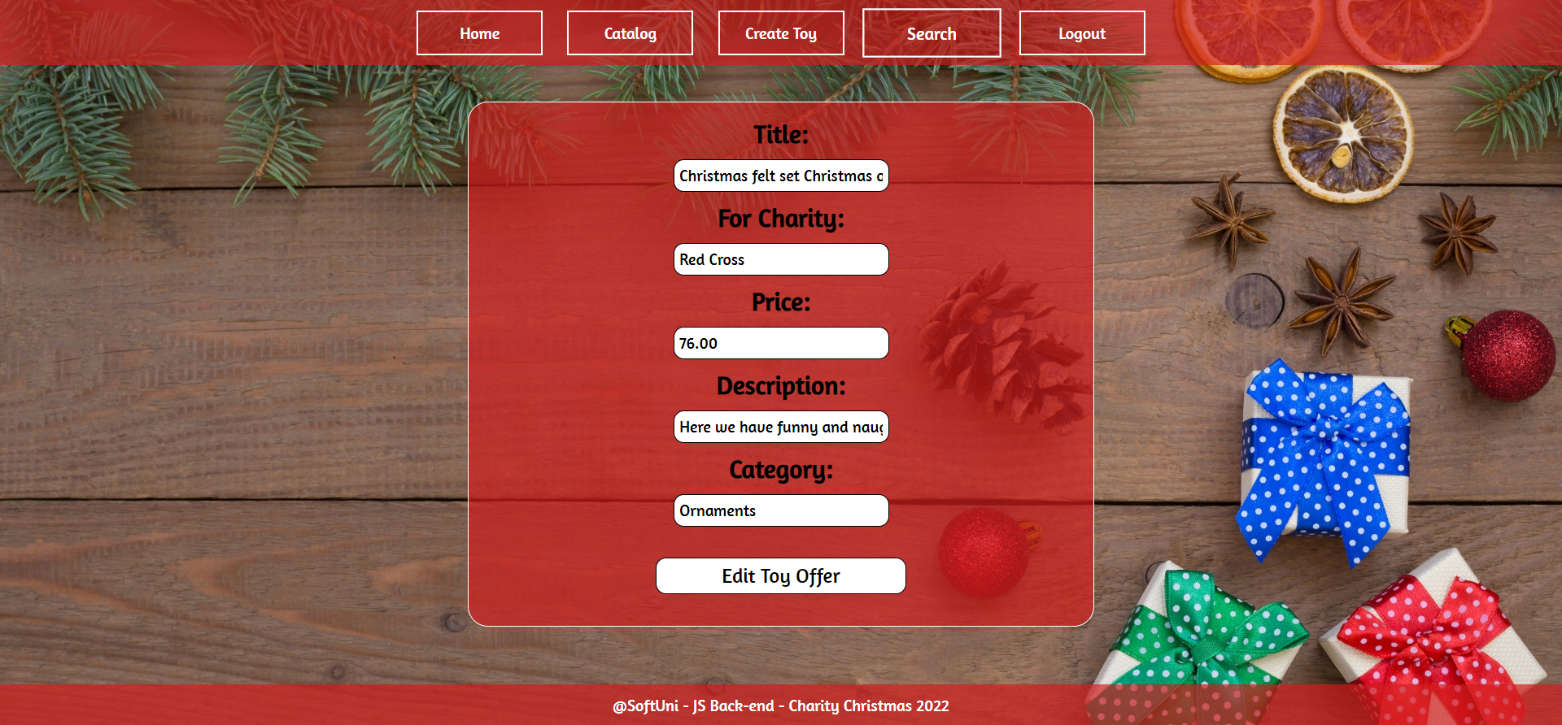

## Security Requirements (Routes Guards) - (10 Pts)

The Security Requirements are mainly **access** requirements. Configurations about which users can access specific functionalities and pages.

* Guest (not logged in) users can access the Home page.
* Guest (not logged in) users can access the Login page and functionality.
* User CANNOT ACCESS THE LOGIN PAGE
* Guest (not logged in) users can access the Register page and functionality.
* User CANNOT ACCESS THE REGISTER PAGE
* Guest (not logged in) and Users (logged in) can access the **Catalog** page (Listed all toys).
* Guest (not logged in) can access the **Details** page without functionality.
* Guests CANNOT ACCESS EDIT AND DELETE PAGES FOR SPECIFIC ITEMS
* Guests CANNOT BUY SPECIFIC ITEMS
* Users (logged in) can access the Home page.
* Users (logged in) can access the Details page and functionality.
  + **Users** (not toy post owners) can **buy toys**.
  + **TOY POST OWNERS CANNOT ACCESS BUY TOYS**
  + **USERS WHO ALREADY BOUGHT A TOY CANNOT BUY IT AGAIN**
  + **Users** (toy post owners) can **Edit** and **Delete** the current toy post
  + **USERS NOT TOY POST OWNERS CANNOT EDIT AND DELETE**
* Users (logged in) can access the **Search** page and functionality.
* Users (logged in) can access the **Create Toy** page and functionality.
* Guests CANNOT ACCESS create toy page functionality
* Users (logged in) can access the Logout functionality.

Use the following view for **invalid** **paths**:

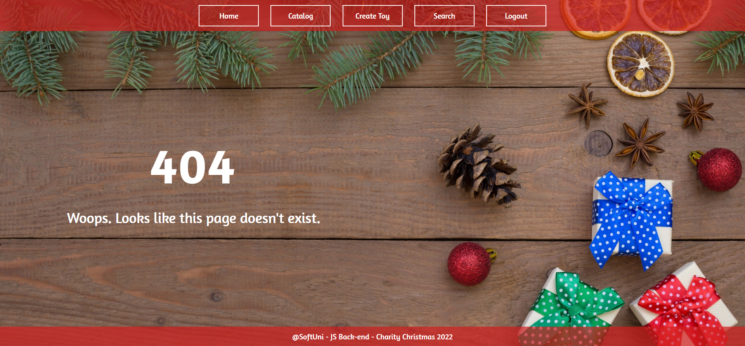

## Validation and Error Handling (10 Pts)

### The application should notify the users about the result of their actions.

In case of an error, you should display div with the class "**errorContainer**"

### You can choose to display the first error or all of them. You have complete freedom to choose the content of the error message you will display.

### Login / Register

You should make the following validations:

* The **username** should be **at least** **4 characters** long
* The **email** should be **at least 10 characters** long
* The **password** should be **at least 4 characters** long
* The **repeat password** should be **equal to the password**

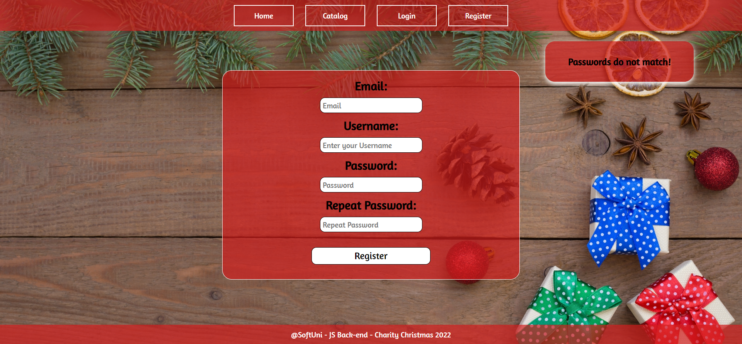

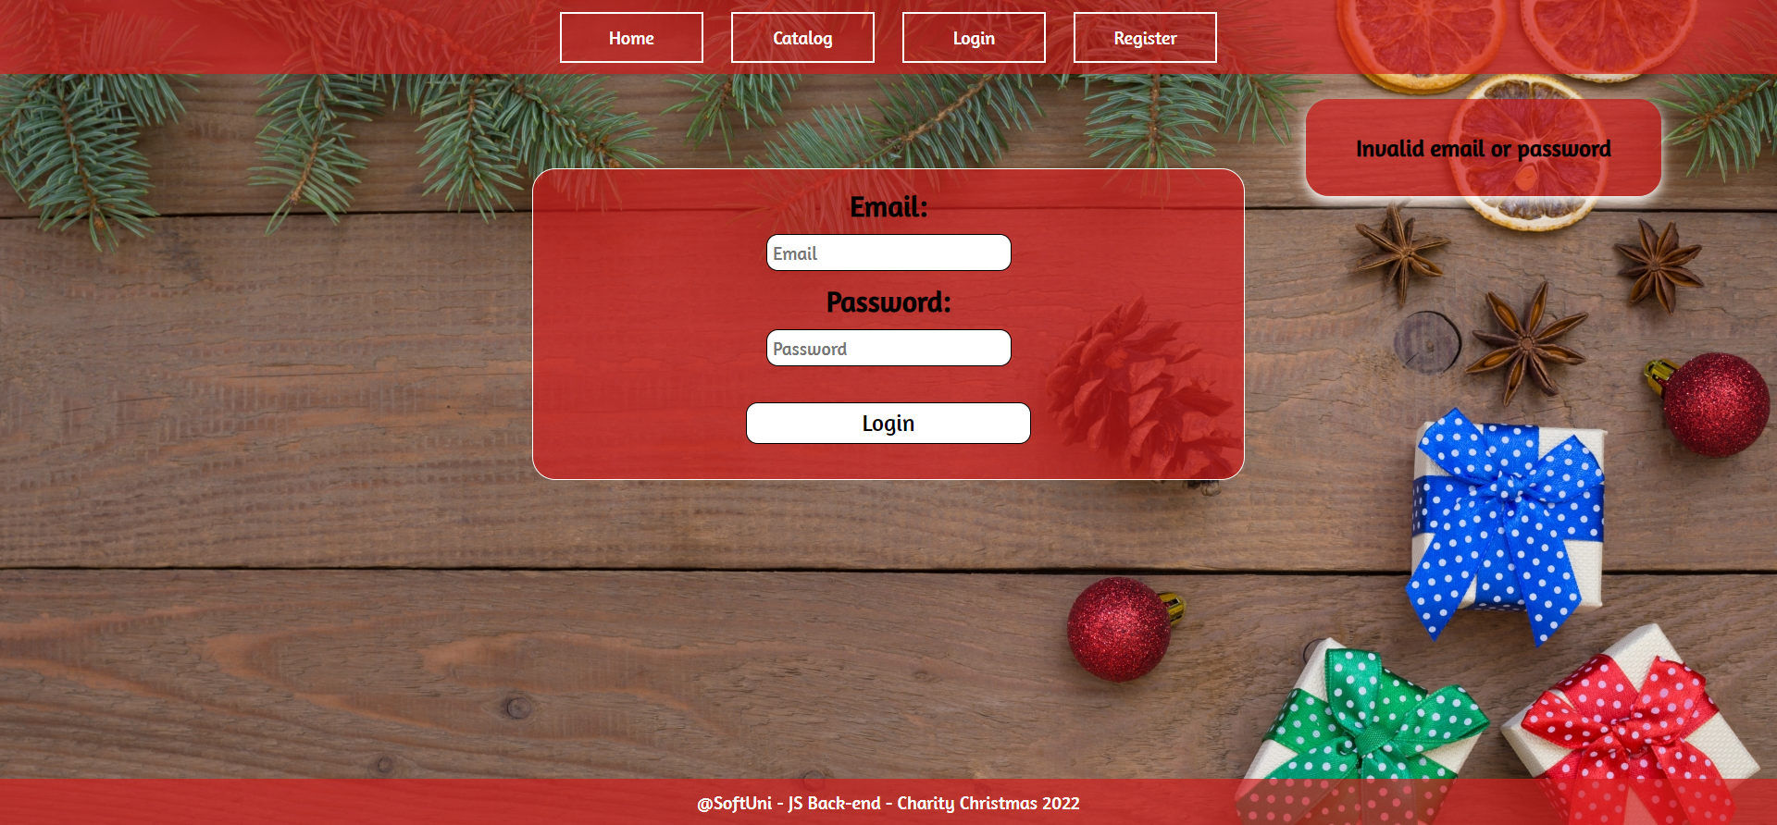

### Toy

You should make the following validations while **creating** or **editing a** **toy post**:

* The **Title** should be **at least 10 characters**
* The **Charity** should be **at least 2 characters**
* The **Price** should be a **positive number**
* The **Description** should be a minimum of **10 characters** **long and maximum of 100 characters long**
* The **Category** should be a minimum of **5 characters long**
* The **Toy Image** should start with **http:// or https://**

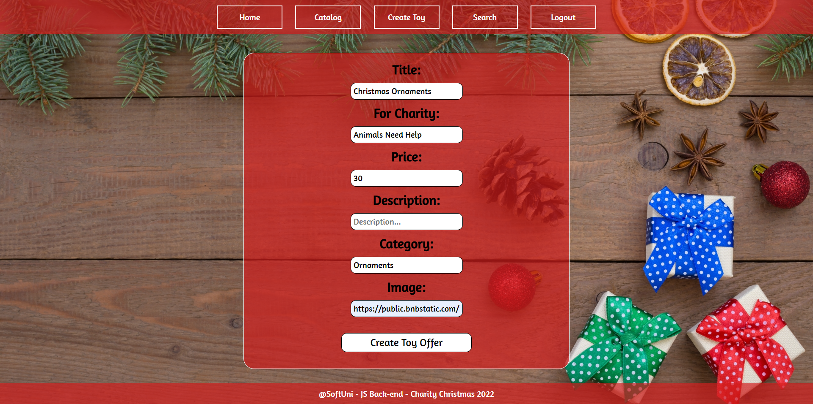

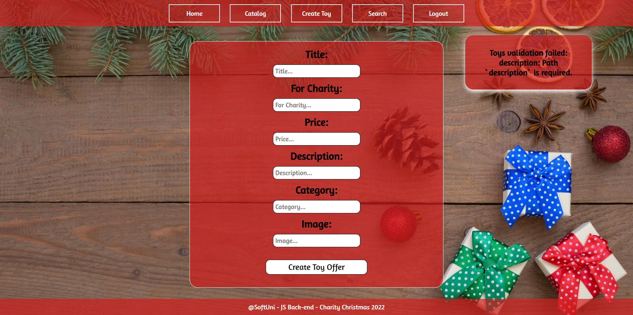

## * Bonus – Search (10 Pts)

Search **for toys**. When you enter the search page, first, you must see **all the toy offers**. Filter all matches by **title** and **charity** (case insensitive). If there is only one criterion, search by that only.

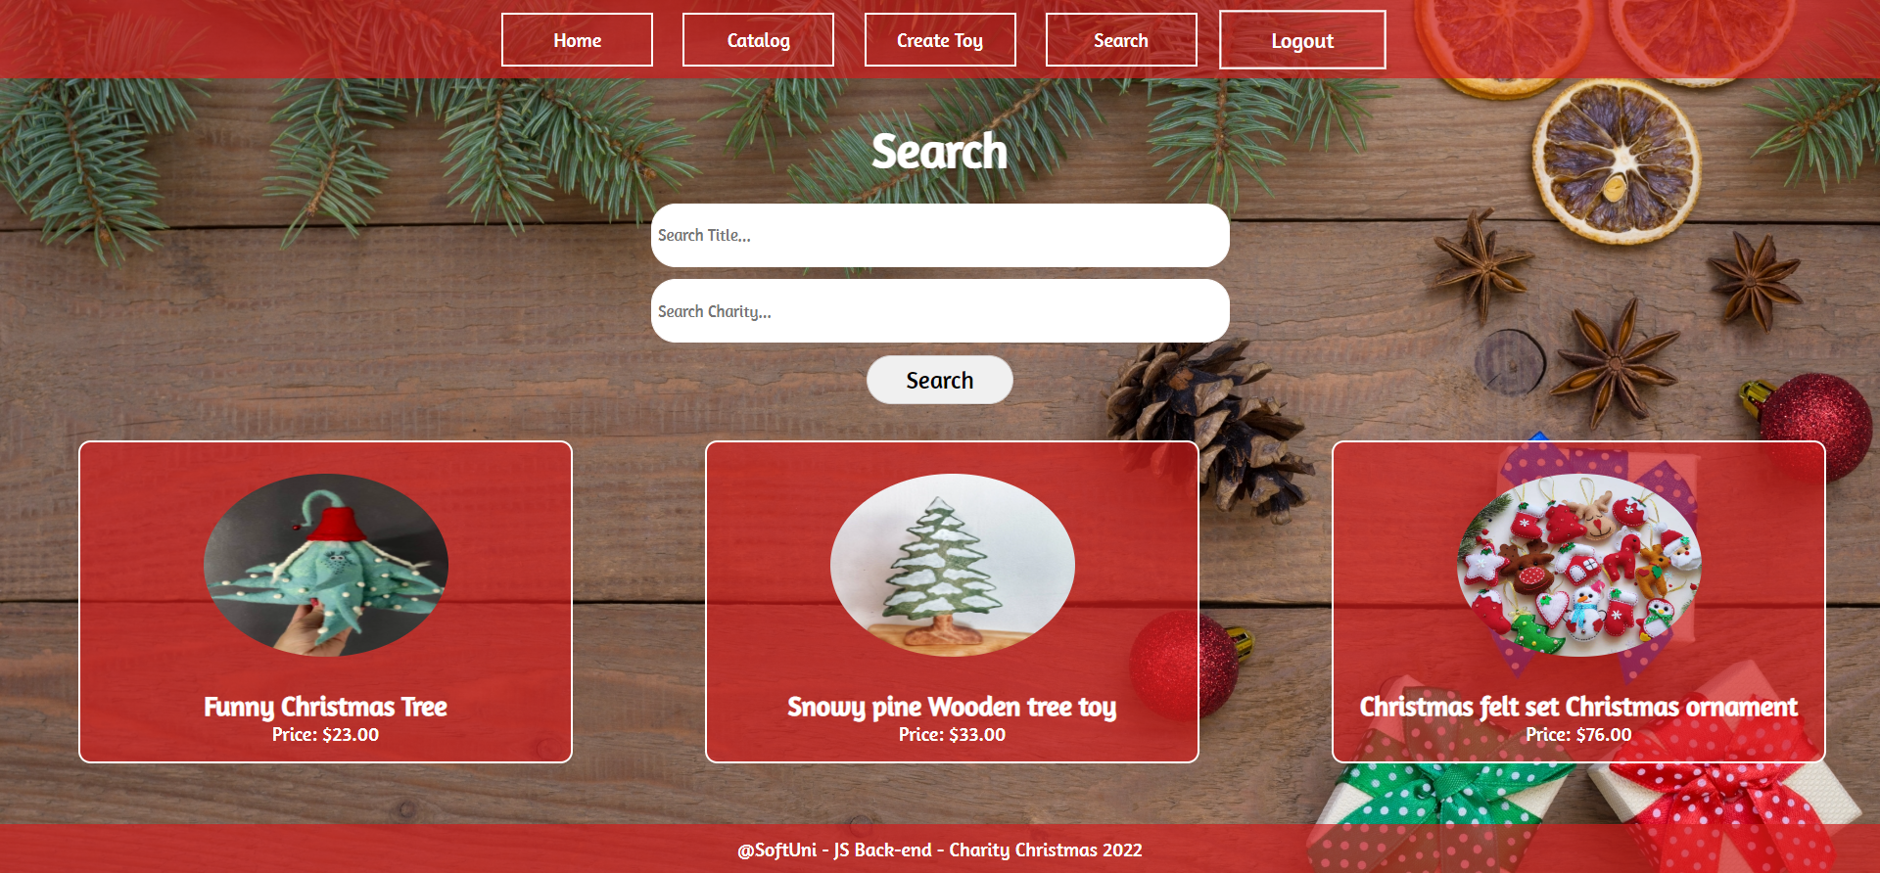

After clicking on the **[Search]** button, If there are any matching matches from the search, show each.

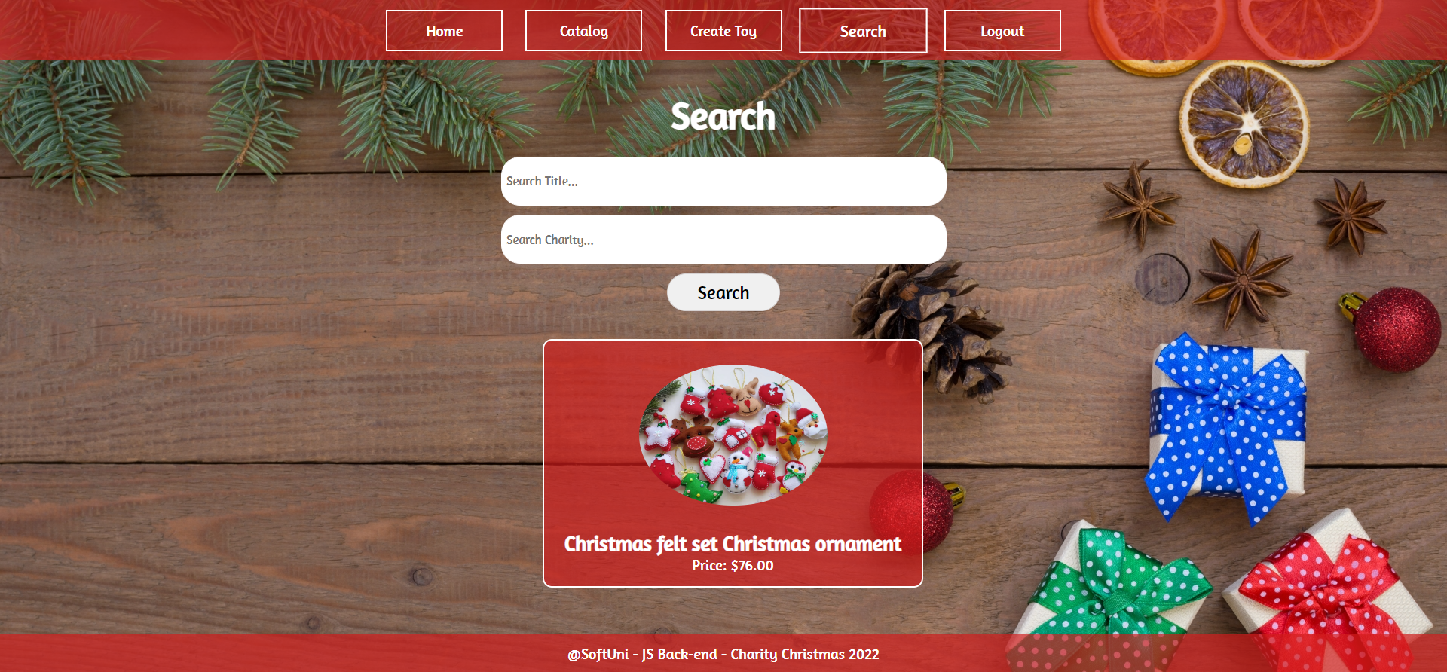

If there are **no** search matches, display:

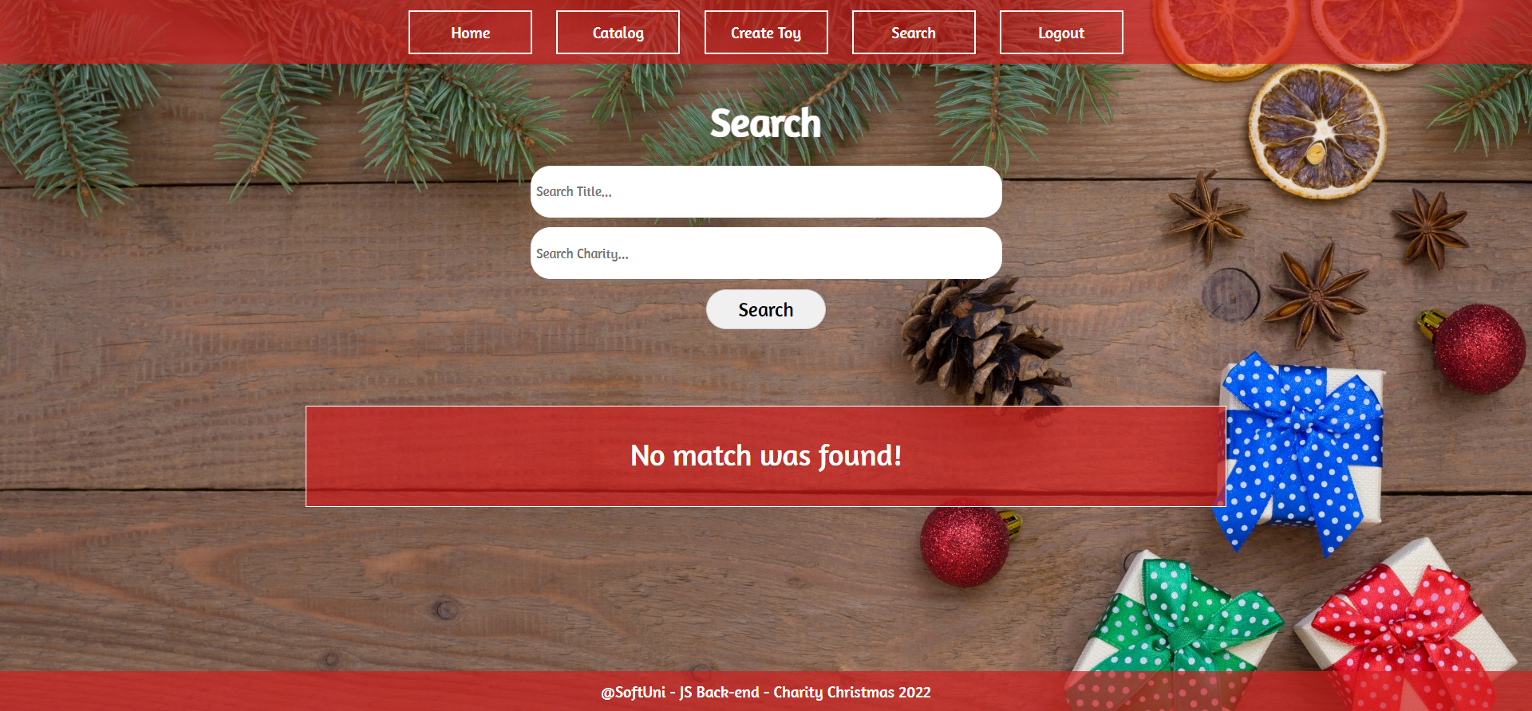

## Submitting Your Solution

Place a **ZIP** file in your project folder. Exclude the node_modules folder. Upload the archive to Judge.









*GOOD LUCK! 😊*